Bitcoin

Bitcoin was invented in 2009 by a programmer known as Satoshi Nakamoto (Grinberg, 2011). The creation of Bitcoin follows precise rules derived from the gold market. So-called “miners” competitively use computer resources to solve cryptographic problems and verify the validity of transactions (Velde, 2013). Success is rewarded by newly issued Bitcoin. The subsequent money creation evolves according to a fixed scheme pre-established by the inventor. Since supply is perfectly predictable,3 Bitcoin is free from any central-bank-like intervention (ECB, 2012). The value of Bitcoin solely depends on supply and demand. Currently, Bitcoins are actively traded against 32 hard currencies on well-organized virtual exchange markets. These markets remain accessible during week-ends, which is valuable to investors, especially in hectic times (Michie, 1999). As of December 2013, the Bitcoin market capitalization was approximately USD 10 billion.

Obviously, Bitcoin is not legal tender. Bitcoins are typically stored in virtual wallets, which attract hackers. As a result, Bitcoin tends to be more volatile than hard currencies, and more prone to speculative bubbles (Grinberg, 2011). On the other hand, virtual transactions are nearly anonymous and have low or inexistent transaction fees.

Exchange platforms for trading bitcoin-Volume and growth in trade over 10-year period

BTC Exchange -created in 2009

BitMex -Launched in 2014

Benchmark rates for bitcoin:-

1.” Bitcoin Ref Rate” (BRR)-Final settlement of bit in USD @ 4 pm London time on each trading day.

2.” CME CF Bitcoin Real Time Index (RTI)”-Real time Bit prices

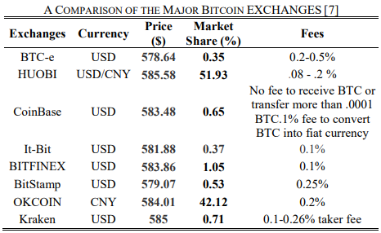

Bitcoin legality -Map of regulatory landscape

Which countries have made it legal,progressive and prohibited.

Plotly or tableau heat map

1.Top 10 countries by volume percentage

Areas of study

1.Performance of BTC against traditional investments -10 year period

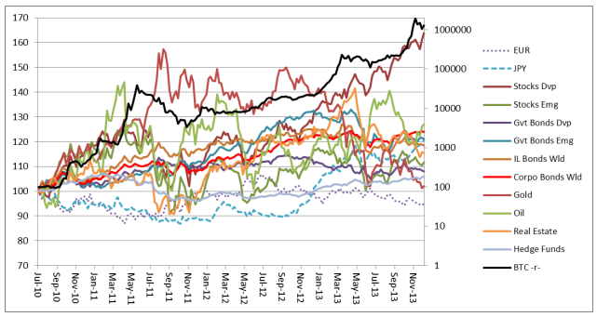

2.Provide a descriptive stat against these as well

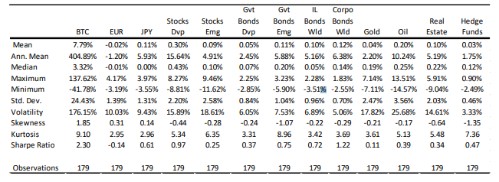

3. Volatility vs return on a weekly basis for BTC-10 year-Std dev of daily returns from inception

4.How it behaves against inflation?

(Usually should provide as a inflation hedge)

5.Correlation matrix between BTC and other assets.

a wider array of asset classes for a longer period and used the concept of risk-adjusted return of the daily returns (calculated through the geometric mean) for every portfolio to highlight the consequences of adding Bitcoin to them.

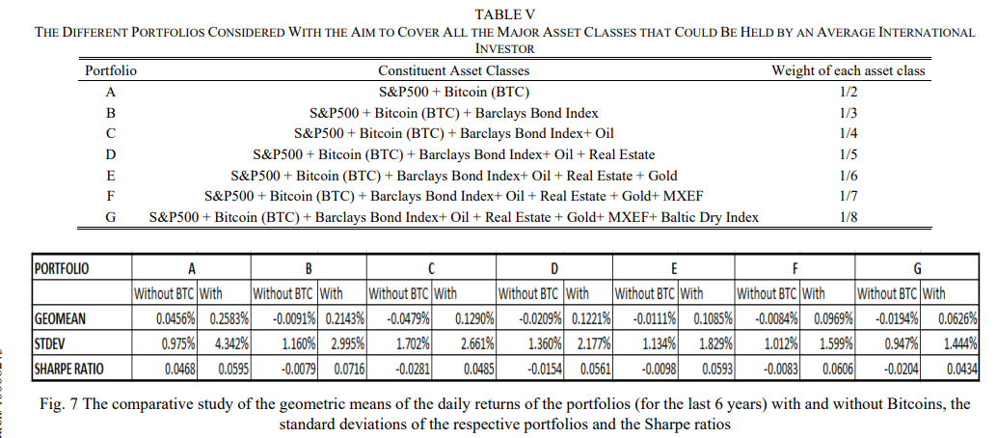

Plot the avg return with n without BTC against Std Dev(risk/vol measure)